**[35] Design DFA Which Input ‘A’ Always Tripled Over Inputs {A,B}**

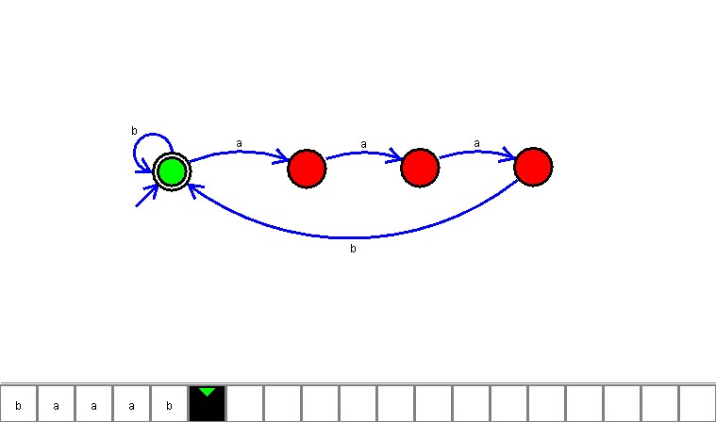

**Result**

The DFA is designed to compute the strings as input using Automaton Simulator